ASSESSMENT TOOL 1

NAME : SHAKTHIVEL R
REG NO : 192524325
COURSE : CLOUD COMPUTING AND BIG DATA ANALYSIS
COURSE CODE : CSA1511

Concept Map 1: Cloud Computing Fundamentals. Include definition, characteristics, benefits, and limitations.

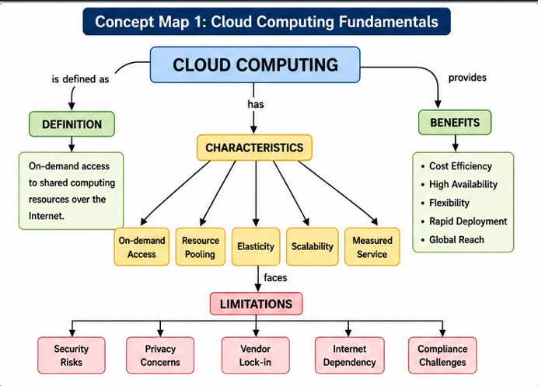

Concept Map 2: Evolution of Cloud Computing. Connect hardware evolution, internet software evolution,distributed systems, and service delivery.

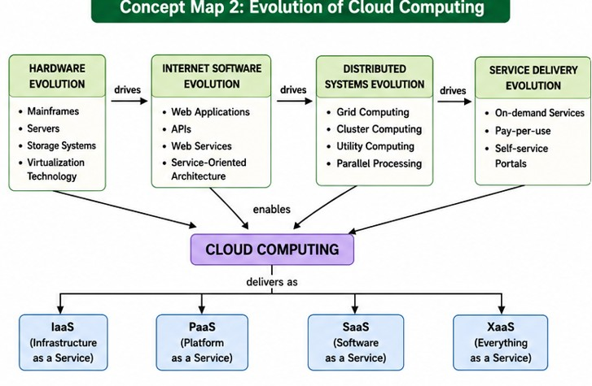

Concept Map 3: Service Models. Map IaaS, PaaS, SaaS, and XaaS with provider responsibilities and user responsibilities.

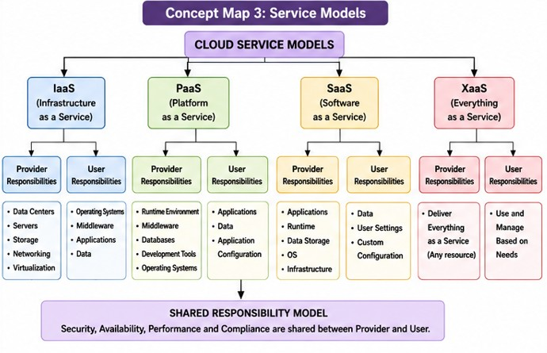

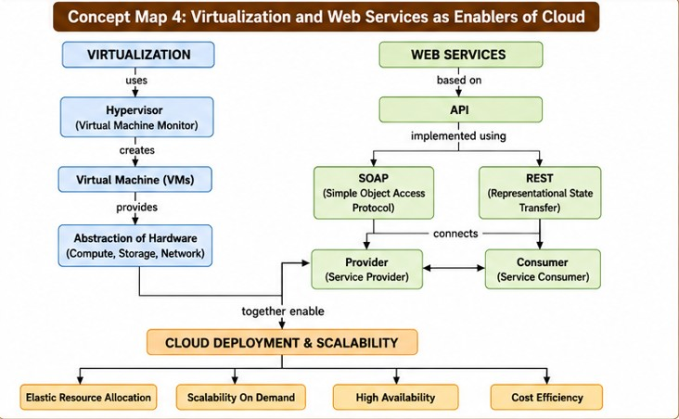
Concept Map 4: Virtualization and Web Services as Enablers of Cloud. Show how these two concepts support cloud deployment and scalability.

